NOTICE OF PUBLIC HEARING

The Board of Aldermen of the City of Twin Oaks will hold a public hearing at 7:00 PM on Wednesday, September 22, 2021 at the City Hall, 1381 Big Bend Road, Twin Oaks, MO 63021, for the purpose of setting tax rates for the 2021 calendar tax year. At this time, citizens may comment on the proposed 2021 property tax rates for each class of taxable property.

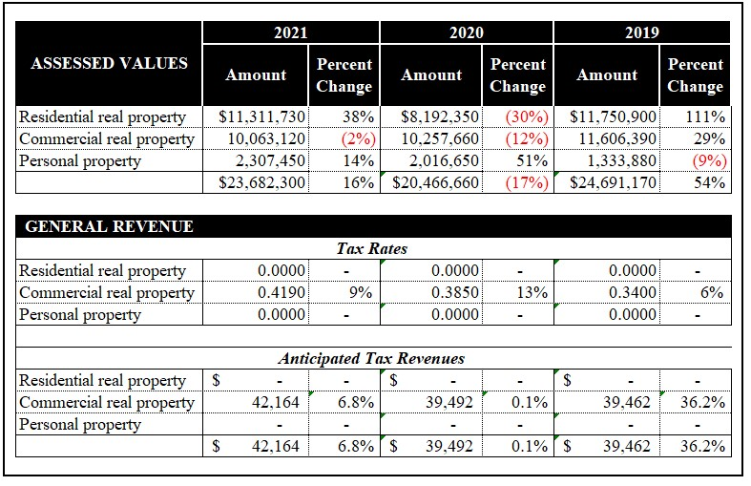

The budget is on file in the office of the City Administrator and Clerk and is available for public viewing in that office at 1381 Big Bend Road, Twin Oaks, MO 63021 during the normal business hours of 8:00 AM to 5:00 PM, Monday through Friday. The budget is also available on the City’s website. All persons interested may appear and be heard at the public hearing.

The proposed tax rates above are based on assessed values provided by the St Louis County Assessor’s Office as of September 15, 2021. They are subject to appeals and finalization by the St. Louis County Board of Equalization, the State Tax Commission and review by the Missouri State Auditor’s Office.

Frank Johnson
City Clerk/Administrator NOTICE POSTED: September 17, 2021

